OLD PART-II FINAL EXAM 2020 SCHEDULE
(For our College students)

UG (Old) Part-II Final Exam 2020 under SKBU will be started on and from 18.11.2020 and will be continued upto 28th November 2020. Exam will be online mode as like as UG(old) Part-III Exam 2020 completed. College will remain open on the Exam Schedule dates.
Exam Schedule and duty chart :

Date of Exam | Name of Exam | Name of TS and NTS to be present in the college
18.11.2020  1st Half(9am to 1pm) | All Hons.-Paper-III | All NTS  Santosh Mahato(SACT)
19.11.2020  1st Half(9am to 1pm) | All Hons.-Paper-IV | All NTS  Khalid Raja Khan
Programme Course
19.11.2020  2nd Half(1pm to 4pm) | Combination Bengali-P-II | All NTS  Khalid Raja Khan  Joudev Banerjee
20.11.2020  2nd Half(1pm to 4pm) | Combination Bengali-P-III | All NTS  Gambhir Kumar
23.11.2020 | History-P-II (1st Half 9am to 12noon)  History-P-III (3rd Half 4pm to 7pm) | All NTS  Amit Mandal
26.11.2020 | Geography- P- II(1st Half 9am to 12noon)  Political Science –P-II(2nd Half 12noon to 3pm) | All NTS  Amit Das
27.11.2020 | Political Science-P-III(1st Half 9am to 12noon)  Physical Education-P-II(2nd Half 12noon to 3pm)  Education-P-II(3rd Half 4pm to 7pm) | All NTS  Nilkantha Moni  Sanjit Rajak
28.11.2020 | Education-P-III(1st Half 9am to 12noon) | All NTS  Arup Nandi

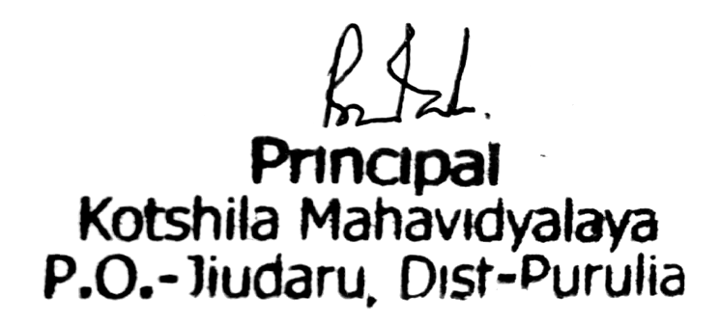
Principal

