Kotshila Mahavidyalaya
Department of English
Notice
Ref. No. KOT/M/ENG/Add On Course/23-24/94
Date: 30.05.24

This is for the information of all students of Communicative English Course, (Session 2023-24) that an MCQ test of 50 Marks on the entire syllabus will be conducted in online mode on 05.06.24 (Wednesday) from 16:00 hours (4 p.m) onwards. Attendance is mandatory in this test. No further chance will be given to absent students for appearing for the MCQ test.

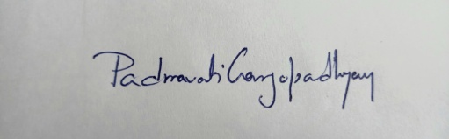
Padmavati Gangopadhyay
HoD, Department of English

