KOT/M/Eng. /IA/II(NEP)/2024-25/132
Date: 26.06.2025
Notice
This is for the information of 2nd semester students of Department of English that they have to give PowerPoint Presentation on any one of the following topics as part of their Internal Assessment of 15 Marks on 04.07.2025 in the college virtual room.

The Topics are:
- Marriage and Wife of Bath in Wife of Bath's Prologue
Or
- The relationship between Bible and the church's teachings and the Wife of Bath.
Marks Distribution:
- Content: 10 marks
- Presentation of the topic: 05 Marks
Student Attendance is compulsory. No excuses will be entertained.

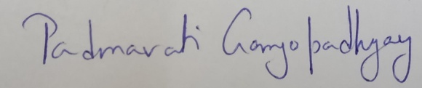
HoD, Department of English

