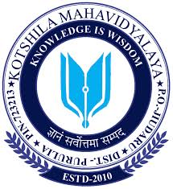

Kotshila Mahavidyalaya
IQAC
Notice
Date: 22.06.2026
This is for the information of all students, teachers and Non-teaching Staff of Kotshila Mahavidyalaya that the IQAC is going to organize few commemorative Programs on Dr. Shyama Prasad Mukherjee as part of the celebration of the life of the great patriot of India from 23 June to 6 July. The title of the event is ”ড. শ্যামাপ্রসাদ মুখোপাধ্যায় স্মৃতি পক্ষ”
Following are the tentative highlights of the first week of the programme.
Date: 23.06.2026
- Inaugural Address and paying tribute to Dr. Shyama Prasad Mukherjee on his Death Anniversary by Smt. Padmavati Gangopadhyay, Coordinator, IQAC, Kotshila Mahavidyalaya.
- Keynote Address by Dr. Prabhat Kumar Mandal, Principal Kotshila Mahavidyalaya.
- Special Lecture of the day titled “Dr. Shyama Prasad Mukherjee: The Man and his Ideals” to be delivered by Dr. Diptimoyee Behera Ghosh, HoD, Department of Education, Kotshila Mahavidyalaya.
- Closing Ceremony by Smt. Padmavati Gangopadhyay , IQAC Coordinator.
Date: 24.06. 2026
- Inaugural Address by Smt. Padmavati Gangopadhyay, Coordinator, IQAC, Kotshila Mahavidyalaya.
- Special Lecture of the day titled “ The Life, Works and Values of Dr. Shyama Prasad Mukherjee” to be delivered by Shri Abhinav Felix Minz, HoD, Department of History, Kotshila Mahavidyalaya.
- Showcasing of documentary film on the life of Dr. Shyama Prasad Mukherjee to the students of the college.
Date 25.06.2026
- Dr. Shyama Prasad Mukherjee Memorial Speech Competition to be organized by Shri Khalid Raja Khan, HoD, Department of Geography, Kotshila Mahavidyalaya.

Date: 29.06.2026
- Students Quiz Competition on Dr. Shyama Prasad Mukherjee.
Date: 30.06.2026
- Students Drawing Competition on Dr. Shyama Prasad Mukherjee.
All students and staff are requested to actively participate in the above-mentioned Programmes.

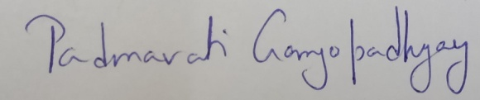
Padmavati Gangopadhyay
Coordinator, IQAC
Kotshila Mahavidyalaya

